The beautiful month of May.
We hope you are all keeping safe and well! Thank you for your wonderful photos and messages, we love seeing and hearing from you all. Please see the suggested activities below. Please don’t feel under pressure to complete all of the activities.
It is important for parents to decide which is the most beneficial way of learning at home during this difficult time.
RE
May is the month of Mary our Mother

We think about Mary every day of the year through prayer. But during the month of May, Mary is specially celebrated by devotions around the world. Being the Mother of Jesus was not an easy task. Mary’s life was full of great joys and great sorrows. By praying to Mary, we can see the way to love Jesus more deeply and appreciate how much he loves us. We think about Mary the Mother of Jesus by saying the special prayer ‘The Hail Mary’. Please encourage your child to say or sing this prayer.
Pope Francis encourages families to pray the Rosary together at home.
This week he said “It is traditional in this month to pray the Rosary at home within the family. The restrictions of the pandemic have made us come to appreciate all the more this “family” aspect, also from a spiritual point of view. For this reason, I want to encourage everyone to rediscover the beauty of praying the Rosary at home in the month of May.”

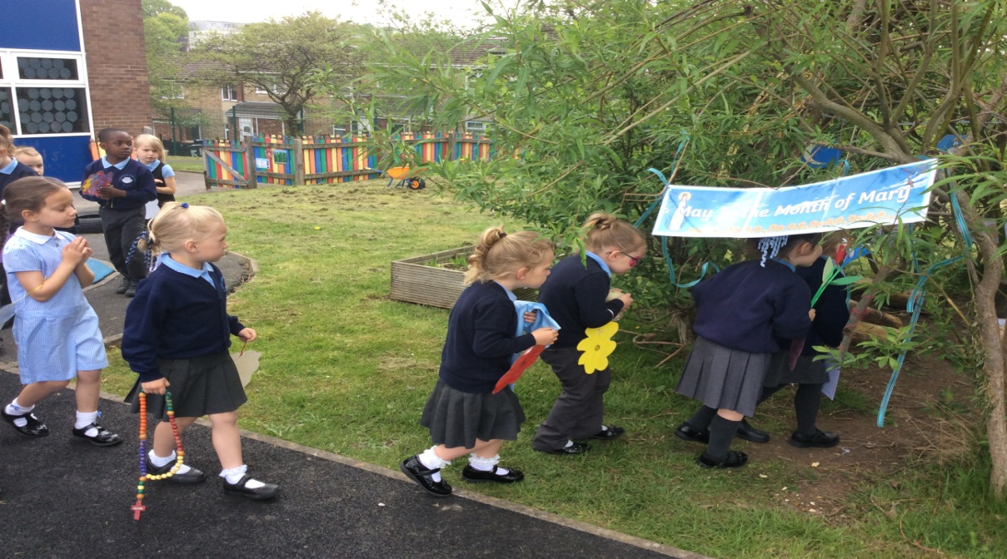
During this time at school we would usually tidy and decorate our outdoor prayer/grotto area in preparation for the ‘Crowning of Mary’.
Please celebrate Mary at home by setting up or adding Mary to your own prayer area. Encourage your child to create and write their own prayer to Mary.

Maths
Please look at whiterosemaths/early years for daily maths lessons.
Count forwards and backwards from a given number
Find one more/less than a given number
Add and subtract (take away) two single-digit numbers (for example, 2 + 4 or 8 - 1) using quantities of objects and counting on or back to find answers
Recognise, count and accurately order numbers 0-20

Phonics
We have now completed all of the set 2 sounds. It is important to your child’s learning that all of the set 1 and 2 sounds are practised each day. Please do not move onto set 3. These sounds will be taught in Year 1 .
If you can please purchase … Read Write Inc. Home: Phonics Flashcards Cards.
Sound Sprint - Make some sound cards (you could use paper). Place and spread them out across the floor. Ask your child to run and stand on the sound you call out. Say simple words as a challenge e.g. f-o-x. eg. m-oo-n 2.
After practising the sounds please complete some of the online activities below …

Read the words in the cloud and then use your fishing skills to try and catch the matching picture card from the river
Can you help the penguins escape? Read the Yeti’s question and choose either e ‘Yes’ or ‘No’ to run across the bridge to safety.
Blend to read the words on the coins. Are they real or fake words?
Practise your tricky words or red words – Tricky word trucks
Remember when reading tricky words they cannot be sounded out they need to be learnt.

Praise is very important, keep telling your child how well they are doing. Try not to correct too often or too quickly. Please don’t get stressed with slow progress. You’re trying your best! Well done.

Reading
Your child can continue to read a story from the free eBook library at Oxford Owl.
Pink Level
Red Level
Yellow Level

On Friday 8th May, the whole country will be commemorating 75 years since VE day (Victory in Europe). Below are a few ideas of what you could do with your child leading up to and including that day.
UNDERSTANDING THE WORLD – PEOPLE
To begin with, it might be very fitting to talk to your child about bravery …Talk to your child about being and feeling Brave!
When are they brave? How are they brave? For example, if they fall over, hurt themselves, they don’t cry too much and then allow an adult to sort out their injury, they are being very brave.
Create some Medals and Badges – award people in your household for being brave in various situations
Talk to your child about the people who help us. This way they have a context and a reason for learning about the different people. Talk about/ find pictures of people who keep us safe [fits in nicely with the current NHS situation]. Talk about how people keep us safe eg parents, teachers, firefighters, police officers etc
CBeebies has lovely programmes about people who help us eg ‘Something Special’ and there are some super stories and activities on this link

Talk about the past
Explain to your child that a long time ago, when great grandma/grandad was very young, they used to wear different clothes to the ones that we wear, they used to have different kinds of holidays, they used to sing different songs and dance to different music. Look together for old photographs in black and white, what can the children notice.

Playtime
Children will love developing their DT and art skills, get some physical activity and learn about the world around them.
It is really strange for children to understand what life was like before tablets, television and computers. Why not play some classic games such as marbles [take care around little ones], hide and seek, statues, hopscotch or card games. This is a great opportunity to use those maths skills eg recognising numbers, measuring whose marble is closest, counting skips etc
Play a game of catch with a ball - when you drop the ball, you lose a point. You could record points using a tally chart and count up who has the most points at the end. CHALLENGE: See if you can catch the ball standing further apart, catch with one hand or use a smaller ball.
If you have a set of skittles, you’re ready to go, if not you can make your own skittles using plastic bottles. Take a plastic bottle and partly fill with soil/ stones or sand to weigh it down. If you don’t have plastic bottles available you could use tin cans for an alternative version. Ask your child to count how many skittles there are to begin with. Roll the ball at the skittles and ask your child to count how many they have knocked over. Can they work out how many are left? CHALLENGE: You could write this out as a subtraction number sentence e.g. if you start with 5 skittles and knock over 2 your child would write 5 - 2. Ask them to count how many are left to find the answer 5 - 2 = 3
Make paper airplanes using this guide. Ask your child/ children to come up with a name for their airplane and write this on the side. Have a competition to see whose airplane will fly the furthest/ highest. You could ask them to create a certificate for the winner.
Teach your children to ‘make do and mend’ What a perfect opportunity to learn to sew eg a simple sock puppet or make something from old cardboard boxes.

We hope you enjoy this week’s home learning.

