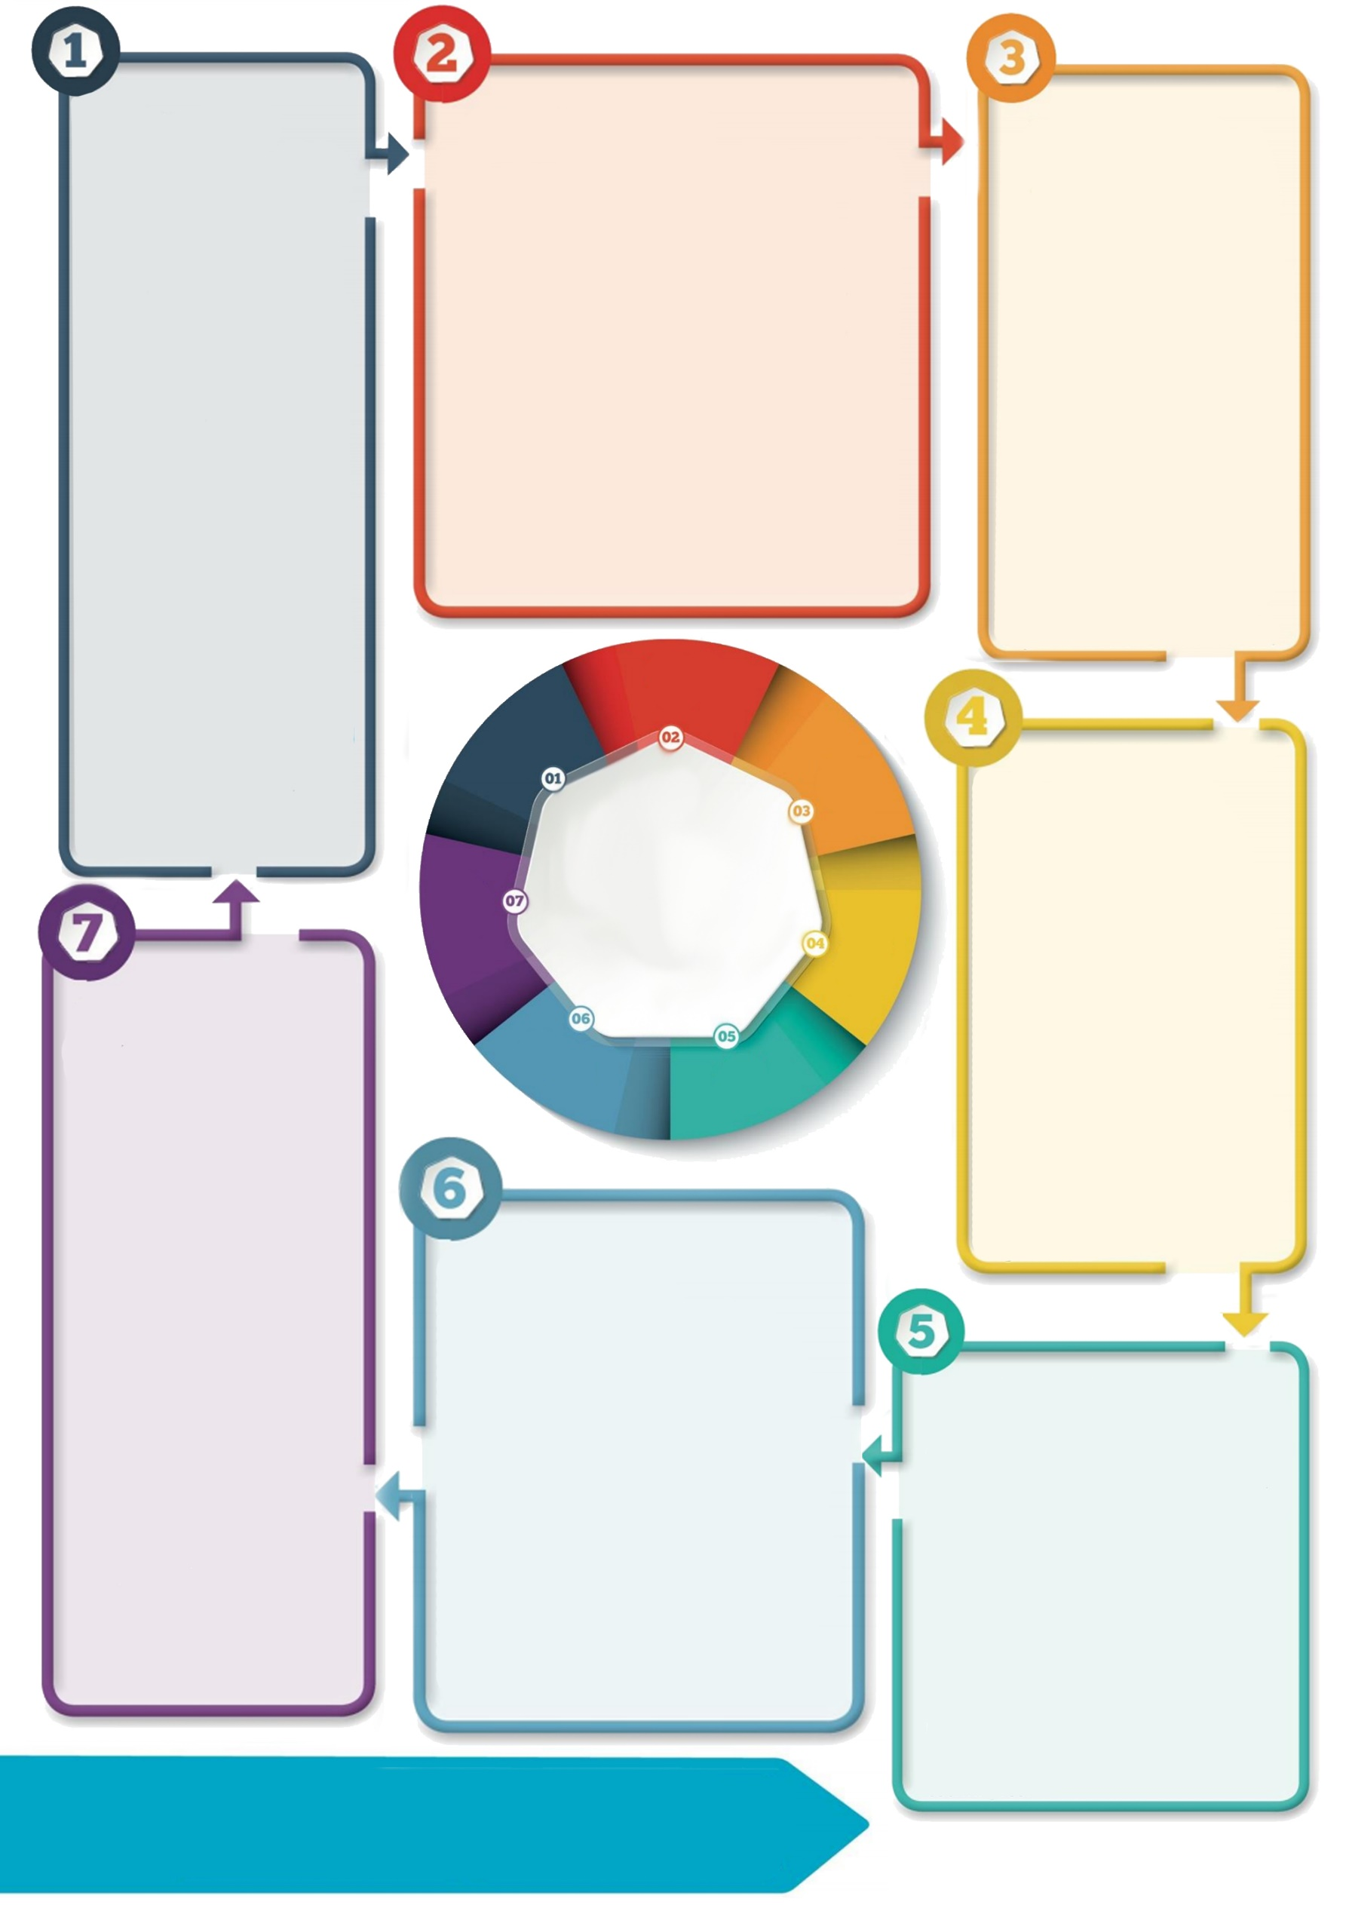

**Self/collective efficacy**

Support children to feel competent as individuals and as part of their community e.g.:

* Point out the skills they developed in lockdown – did they walk more, learn to identify flowers, cook or become more independent learners?
* Praise them specifically for the transition e.g. talk about out how well they are coping with the changes to school
* Talk about your child’s school, class and teachers positively.

**Safety**

Promoting a sense of safety will be important for children as they go back to school, e.g.:

* **Physical safety**: talk to them about what is happening at school to keep them safe. Ask your child’s school if they’ve prepared any videos, factsheets or letters about any of the school routine changes and talk through them with your child. Minimise / manage access to news and keep conversations about Covid-19 in front of children as positive and calm as possible
* **Psychological safety:** talk to your child about the staff in their bubble or class and identify who they can go to with any problems they might have. Some children may benefit from a named key adult.

*Hobfoll *et al*. (2007) *Five Essential Elements of Immediate and Mid–Term Mass Trauma Intervention: Empirical Evidence*

**Contact details: If you’d like to discuss further please contact the Educational Psychology Service (EPS@salford.gov.uk or educationpsychology@tameside.gov.uk)**

**Further thinking**

- Some children may find the transition back to school more difficult due to their individual strengths and needs. If you feel they may struggle it could be useful to **contact your child’s school’s** **SENCo** and discuss individual support for your child.

- Find practical **strategies** from the **NSPCC** here: <https://www.nspcc.org.uk/keeping-children-safe/away-from-home/at-school/>

- Resources for children to help them **feel** **calm** from **Childline**:

<https://www.childline.org.uk/toolbox/calm-zone/>

- The **Anna Freud Centre** collated these strategies for self-care from young people: <https://www.annafreud.org/on-my-mind/self-care/>

**Connectedness**

Following isolation, supporting connection with others is important e.g.:

* Plan how to show affection to friends e.g. thinking of alternatives to hugs;
* Keep your child in mind whilst at school e.g. tell them you’ll think of them/ look at their photo during the day;
* Schedule time each day to give your child your undivided attention, even for a few minutes. Do an activity they choose e.g. pretend play, a game, a walk together or baking;
* Connect with friends / family you can’t see (e.g. if shielding/ in other bubbles) by email, messaging or video calls.

**Hope**

Hope helps us to recover and work towards a happier future, e.g.:

* Make sure you connect with your own hope – are there plans you can make and work towards yourself?
* Ask your child what they hope for in school and help them to work towards it
* Reassure your child that in the longer term we will feel much more positive
* Find stories of hope in the news and discuss them with your child.

**Calm**

Promote a sense of calm, e.g.:

* Talk to your child about school calmly and positively – they will pick up on your feelings
* Use a calendar to show when they return to school
* Accept all feelings as normal during this time
* Allow time to ‘decompress’ at the end of the school day – whatever this looks like for your child
* Practise calming strategies like deep breathing, yoga and mindfulness.

**Transition back to school**

**Supporting your child’s wellbeing during the return to school**

**Introduction**

Transitions can be challenging, and the extra anxiety and disruption related to Covid-19 may add to the challenge of returning to school for some children. A large study* found five key areas that support recovery following a traumatic event: a sense of **safety, calm, self- and collective efficacy**, **connectedness** and **hope.** During the return to school it will be important to think both about how to prepare them practically for the changes in their routine as well as supporting the **psychological wellbeing** of your child. Here are some tips and strategies for each area.